LED FLOODLIGHTING

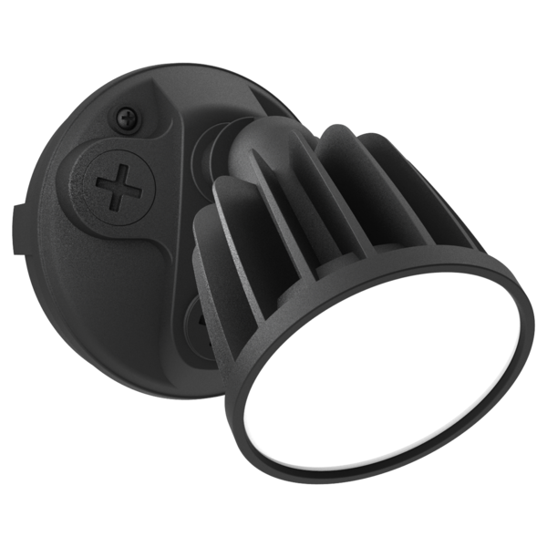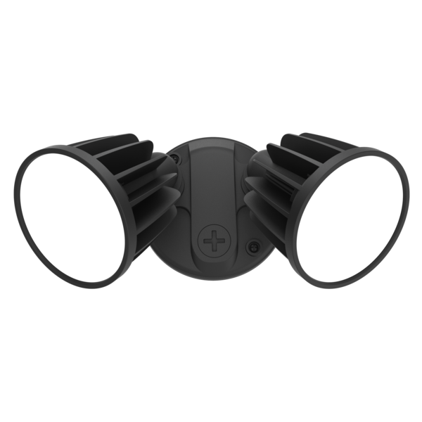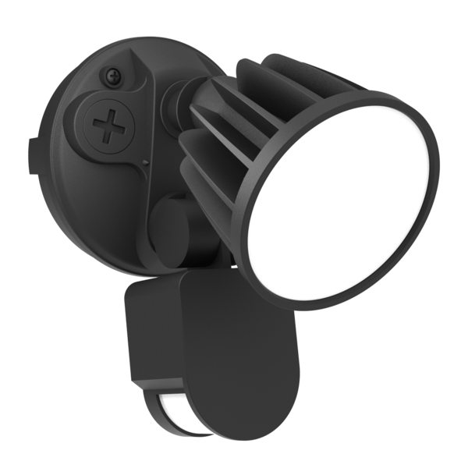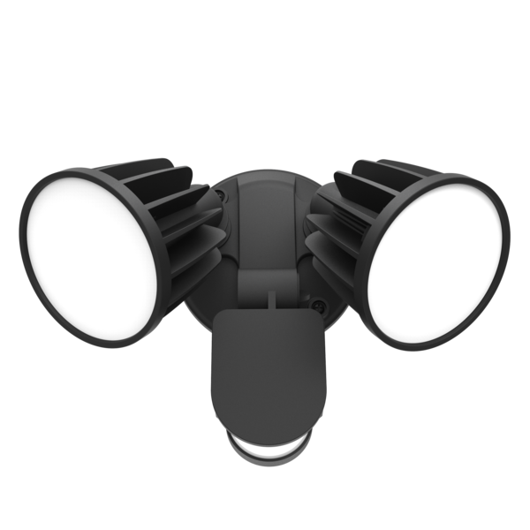

- AVAILABLE IN BLACK OR WHITE
- DURABLE POLYCARB MOUNTING BASE
- OPAL POLYCARB DIFFUSER
- 15WATT
- TRI COLOUR 3000K, 4000K, 5700K
- LUMENS 1200lm, 1300lm, 1250lm
- BEAM DISTRIBUTION 100deg
- HIGH EFFICIENCY LED CHIPS
- INTEGRAL NON DIMMABLE LED DRIVER

SENSOR MODELS:
- INTEGRAL PIR MOTION SENSOR
- DETECTION DISTANCE 12m AT 2.5mh
- DETECTION ANGLE 180deg
- MANUAL OVER-RIDE FUNCTION
- TIME AND LIGHT LEVEL ADJUSTMENTS

*SINGLE FLOODLIGHT PART NUMBER SE7080/1TC-BK

*SINGLE FLOODLIGHT WITH SENSOR PART NUMBER SES7080/1TC-BK

*TWIN FLOODLIGHT PART NUMBER SE7080/2TC-BK

*TWIN FLOODLIGHT WITH SENSOR PART NUMBER SES7080/2TC-BK

